The Best Standard Deck That You're NOT Playing
Tom Guevin
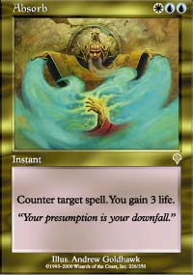
When you think of Standard, decks like Fires, U/W Angel, and Nether-Go come to mind. These decks had high visibility at both States as well as Pro Tour - Chicago, mainly because they utilized cool new Invasion cards like Fires, Jade Leech, Absorb, Fact or Fiction and Undermine.
For States and for Chicago, the two best decks were under the radar, not getting a lot of press, yet getting good results. Most everyone now knows of Rebels and its strong consistency and favorable matchups against Fires and Fact or Fiction-based Blue control.
But notice I said the two best decks. The other deck I'm referring to is Blue Skies. I feel Skies is the best deck in Standard right now, narrowly edging Rebels. Why didn't Skies dominate States and the Pro Tour? There are several reasons. First and foremost is that the best version of Skies wasn't played at either event. The Skies decks played were too close to their MBC version, and unlike Rebels no one really advanced the archetype to its modern best build form. If you told me that you wanted to play Rebels in Standard, I'd say play Kai Budde's or Warren Marsh's deck from the PT. They're nearly identical except that Kai ran Brushland and Wax/Wane while Warren ran Plains and Disenchants. If you told me you wanted to play Fires, I'd say go read Zvi's articles and then you'd have a decent deck. If you wanted a metagame R/G/W deck, then Kibler's deck is great. And if you wanted to play a Fact or Fiction blue deck, I'd say don't bother as the time limits don't allow them, especially if you get paired against another control deck.
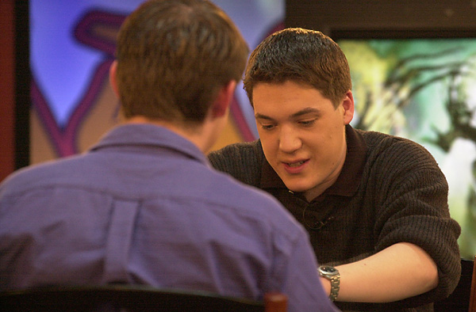
But if you wanted to play Skies I couldn't with a straight face tell you to play Elarar's deck or Ed Fear's deck and especially not Maher's deck. None of their decks are optimal and can't beat the field. Elarar had some good ideas, but his failure to be able to board up to 4 Wash Out against Kai cost him a PT crown.
So you're wondering what is the optimal way to build Skies? Well first, throw your MBC list out. In Standard, playing Skies is about playing the fastest most efficient creatures backing them up with the best free spells possible.
In MBC, Daze was powerful, mainly because Skies had a lower curve than most of the decks in the field. Skies could play turn 2 and 3 creatures, and when the opponent went to cast the first creature on turn 3 (an Idol, Crawler or Airship), Skies would Daze without really any setup. This was especially the case against decks that ran powerful 4 and 5 casting cost spells, like Parallax Wave, Saproling Burst, and Thrashing Wumpus. In Standard, Daze is much worse. Most decks have a much lower curve than you and/or contain mana producers. Dazing early just sets you back a turn from developing your offense.
Another bad transfer card is Waterfront Bouncer. Most decks in MBC had to rely on creatures to win, from Rebels, to Green critters to Mageta. Bouncer ruled that format. In Standard, Bouncer is worse, as there is too much targeted removal, too many fast creatures and too many decks that don't rely on creatures to gain control of the game. Wash Out is just a better choice, as it is a one-card clean answer to a horde of White or Green creatures. And against decks packing Story Circle, Nether Spirits, and such, it's fine as a reset and then counter button.
So here's the optimal build as I see it for Skies in Standard and I'll explain my choices below:
4 Spiketail Hatchling
4 Chimeric Idol
4 Rishadan Airship
4 Troublesome Spirit
4 Thwart
4 Foil
4 Opt
4 Gush
4 Wash Out
21 Island
3 Sky Diamond
The creature count should seem low. Only 16 creatures is risky, but the deck manipulation amplifies the creature count nicely. Notice I'm playing only the "best" creatures available. I don't have Cloud Sprite, Cloudskate, Drake Hatchling, etc. The creatures either counter spells or attack for 3.
Let's talk about the counters: the 8 "best" counterspells for the deck. These are true counters, that aren't dependant on the opponent being tapped out or you being untapped. They combo well with creatures that force you tap out, as well as with Wash Out.
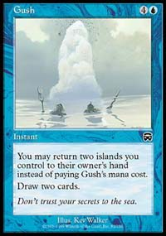
In terms of deck manipulation, 4 Gush is there because you want to outdraw your opponent. You never want to miss a land drop and you don't want to lose to any Probe nonsense. You'll never run out of gas with 4 Gush. Many people think 3, because you ONLY want to draw one, but that is a poor argument. If you WANT to draw one you play with 4. Opt is a card similar to Impulse in both design and history. When Impulse came out, it saw little play in Constructed and Limited. But eventually it caught on as a staple card for blue decks. The same will be true for Opt, and the craze has already started as the best version of Blue/White and Black/Blue at the Pro Tour both contained 4 Opt. But only one Skies deck that made Day 2 at Chicago had 4 Opt. The other eight were simply wrong. Opt is so good, as it gets you to the card you need faster and more consistently than any other one casting cost deck manipulation spell. Against Rebels you want to draw as many Wash Outs as possible, so use Opt aggressively to get them. Against control, you want as many flying threats and counters as possible so you use Opt to get there. And Opt can always get you to your 2nd Island.
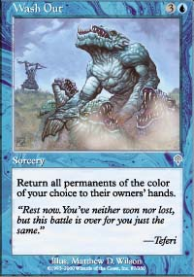
Ah Wash Out. While everyone was chasing Utopia Trees, Fact or Fiction and Undermine, Wash Out was in the background not getting a lot of press. It's just an amazing card. For four mana, you reset your opponent. Because of Wash Out, Rebels need a whole new plan against you, like Wrath of God, Seal of Cleansing and the like. And Wash Out is great against Fires or any deck that relies on Elves. Let's bounce your Green Fatties, Fires and all your Elves while I'm at it.
The mana. Notice 21 Islands and 0 special lands. No Ports, Dust Bowl, Edge, Skerry, or Temple. Why? Islands are just more powerful. Remember back in the day when all you'd see were people sacrificing 2/4 Mountains to Fireblast/Double Fireblast you? Now you don't hear people sacrificing Mountains (Mogg Alarm is terrible), nor do you hear people sacrificing or bouncing Plains, Forests or Swamps. Instead, Blue got all the cool free spells, all involving the use of Islands. You can return Islands to you hands to draw cards and counter spells and then discard Islands to counter spells. Islands are the best land in Standard, better than even the mighty Port.
Why 3 Sky Diamonds? Well many times you want to ramp to 4 mana ASAP, to get around Port or to play Spirit or Wash Out. The Diamond does this as well as giving you another second turn play. In addition, when you're constantly returning land to your hand, having another mana source is play is useful. Plus they're a natural combo with the Rising Waters in your SB and are protection from any sort of land disruption strategy.
The main deck is 16 of the most efficient creatures, 8 free counterspells, 8 effective "free" card drawers and 4 cards to reset the opponent's board. The main deck seems pretty efficient right?
Well the sideboard just gets better.
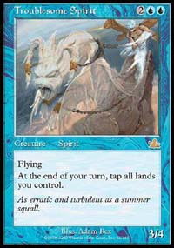
In the Sideboard more free and cheap spells abound, to set your opponent back. Take Submerge for example. For the cost of zero mana against a green deck, you put any creature to the top of the owner's deck. Forget about green creatures, which you usually stop with Wash Out, Submerge is especially good against Chimeric Idols, setting the opponent back two turns of attacks. And you can always protect your 3/4 Spirit from double Urza's Rage with it, too. Again zero mana. Time advantage. At what cost? A card and controlling an Island.
The next slot is the bounce slot. Sometimes 4 Wash Out (even with 8 deck manipulation spells) isn't enough. You need to power up. My current choice is 4 Withdraw, which is like a Wash Out against Rebels and is great in the mirror against the 8 tap out creatures the opponent will have. Waterfront Bouncer is also a possibility in this slot, especially if your metagame is zero Skies and mostly Kibleresque Red Zone decks. Again the theme is spending 2 mana to bounce things that the opponent spend many more mana to cast.
Overburden is garbage. It's only good on turn 2 and even then it sets you back as well. The fallacy of Overburden is that the Rebel deck must search to beat you. Kai didn't have to search to beat Elarar, he just played creatures and beat down with Port cover.
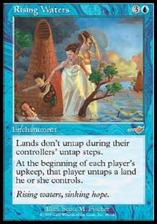
With all this space devoted to beating creatures, you need something against control, especially to replace your 4 main deck Wash Outs. The answer is 4 Rising Waters. Not 3, but 4. You want to see one on the draw. Your deck can function under it, where the opposing control deck can't. Your card drawing is all 1 or 0 mana, while the opponent's is 1, 2 and 4. If Waters hits play and stays, you should beat just about any control deck. And the threat of Waters against non-control decks is huge as well.
Three Misdirections round out the sideboard nicely. Sometimes you just get outcountered and outdrawn. These will help prevent that and help you force Waters through. For a while, I was boarding them in against Fires that had Assault/Rage and sideboarded 4 Simoon. Simoon me? No Simoon you and all your Elves and Birds. Then I realized you can't Misdirect Simoon. Anyway, Misdirection is still a viable SB card choice though not as palatable as before.
So, the last three sideboard slots have to be metagame driven. If you think there will be a lot of control decks go with Misdirection, Disrupt or basic Counters. If you need more bounce you could always use Boomerang. Bribery is slow and too expensive for my liking, though it's certainly fun to play with Two-Headed Dragon, especially in a mono Blue deck. Glacial Wall is only for those especially paranoid about Green.
I want to end on the same point as I began. Just because the pros stop working on a format, doesn't mean that format is stale, old and boring. The pros missed the mark on Skies in Chicago and it cost them. The bottom line is that the best decks in Magic are the ones with the cheapest, yet powerful spells. And Skies certainly hits that mark for Standard.

